# *RozgarLink*

## Overview

RozgarLink is a platform designed to connect daily wage workers and semi-skilled individuals in India with potential employers. It provides a simple, accessible solution to address the challenges of unemployment among workers in non-technical sectors like construction, hospitality, and small-scale industries. The platform simplifies the hiring process, ensures fair wages, and creates transparency in the job market, thereby empowering workers and improving employer access to skilled labor.

## Key Features

#### For Workers

* **Profile Creation**: Workers can register with their name, contact details, skills, and preferred work type.
* **Job Discovery**: Workers can browse available jobs nearby and apply based on suitability.
* **Daily Availability**: Toggle feature for workers to mark themselves available or unavailable for the day.
* **Application History:** Access a summary of completed jobs, wages earned, and ratings received.

#### For Employers

* **Job Posting**: Employers can post job openings with details like title, wages, duration, and location.
* **Worker Search**: Employers can search and filter workers by skills and proximity.
* **Application Management**: View worker applications, shortlist candidates, and confirm hiring.

#### For Organizations

* **Organization Profile Creation:** Register as an organization, including name, contact details, services provided.
* **Team Management:** manage workers based on roles and skill.
* **Apply for Team-Based Jobs:** Organizations can browse and apply for jobs that require teams.
* **Performance Tracking and Reviews:** Access a summary of completed jobs, ratings, and reviews for the organization as a whole.

## Actors and Accessibility

1. **Worker**: Registers on the platform, browses job opportunities, applies, and manages work history.
2. **Employers**: Post job listings, hire workers/teams, and manage job completion.
3. **Organizations**: Register teams of workers, manage team members, and apply for team-based jobs.
4. **Platform Administrator**: Manages user accounts, resolves disputes, and ensures platform integrity.

## Future Scope / Ideas

(just for documentation purpose, not for implementation)

* **Skill Training**: Incorporate short courses or tutorials to help workers improve their skills.
* **Payment Tracking**: Add functionality to track and record payments between employers and workers.
* **Government Schemes Information**: Help workers and organizations learn about government schemes through blogs or links to official websites that support employment, skill development, or financial assistance.
* **Chat Feature**: Communication between workers, orgs, and employers, making the hiring process more efficient.
* **Notification Service:** Receive updates on new job postings, application status, and total applications via the app or SMS.

## Initial Implementation Details

1. Worker and Employer registration systems.
2. Job posting, searching, and application functionalities.
3. Matching algorithm for jobs and workers based on location and skills.
4. Dashboard for workers and employers to track activities.

## 

## Features

* Signup and Sign in
* Profile Page (Personal Information, and official details, working preferences)
* Search Jobs Page, (sorting and filtering jobs)
* Job Page (Job description and details, application functionality - a form to fill required details, Report Job)
* Employer Page (Employer Details), all jobs posted by that Employer.
* Dashboard (Calendar, Jobs applied, Application status, Ratings)

Job Application Functionality:

* Worker applies for the job on the job page, using simple Easy Apply and a Form if needed by the employer.
* On applying, applications will be created and will be visible to employers.
* If an application is selected by the Employer, Application Status will be updated to Shortlisted / Selected but not confirmed.
* Worker receives a final acknowledgment/confirmation form on the same job page consisting an Accept / Decline option on which the application and job status will be updated. Hence that Job won't be visible now to the rest of the workers.
* the dates will be blocked for the Worker.

## INITIAL DB STRUCTURE

### Workers Table

| Column Name | Data Type | Description |
| --- | --- | --- |
| worker_id |  |  |
| name |  |  |
| contact_number |  |  |
| email |  |  |
| password |  |  |
| skills |  |  |
| location |  |  |
| availability |  |  |
| rating |  |  |
| created_at |  |  |
| language |  |  |

### 

### Employers Table

| Column Name | Data Type | Description |
| --- | --- | --- |
| employer_id |  |  |
| name |  |  |
| contact_number |  |  |
| email |  |  |
| password |  |  |
| sectors |  |  |
| location |  |  |
| verification_status |  |  |
| rating |  |  |
| created_at |  |  |
| language |  |  |

### Jobs Table

| Column Name | Data Type | Description |
| --- | --- | --- |
| job_id |  |  |
| employer_id |  |  |
| title |  |  |
| description |  |  |
| skills_required |  |  |
| wages |  |  |
| duration |  |  |
| status |  |  |
| location |  |  |
| created_at |  |  |
| deadline |  |  |

### Applications Table

| Column Name | Data Type | Description |
| --- | --- | --- |
| application_id |  |  |
| job_id |  |  |
| worker_id |  |  |
| status |  |  |
| applied_at |  |  |
| updated_at |  |  |

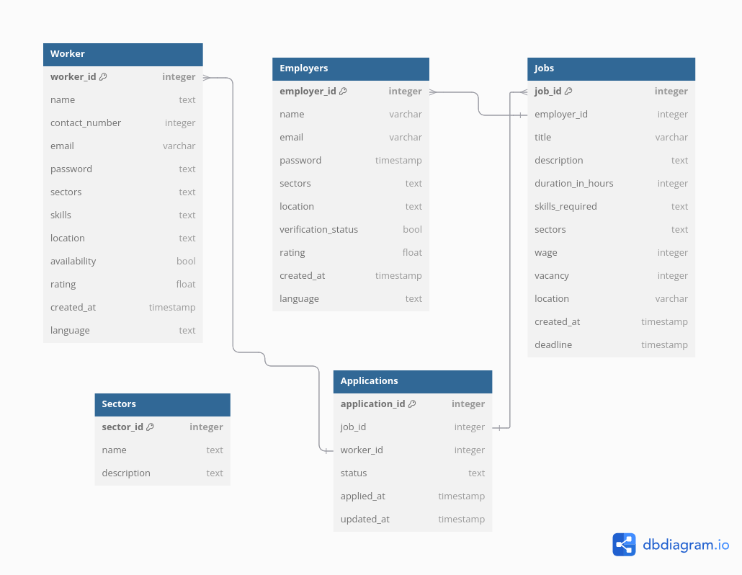

## API Documentation

[Postman API Documentation](https://rozgarlink.postman.co/workspace/My-Workspace~d221b2fc-158e-43f4-8167-12afbf981afe/collection/41360468-bd8f1f78-169b-4571-9fce-2fc47c4f66b9?action=share&creator=41360468)